1.1

Exercise 1: Filterfir consists of 2 components H and X. The command returns the filtering operation of X which has an impulse response of H. The Y is the output of the function, executed by FILTERFIR(H, X).

Exercise 2: The command generates the 10-point average which has a amplitude of 0.1.

1.2

Exercise 3: In between the %begin and end calculation, omega is defined as a period of 2\*pie/N. The function FF gets assigned an expression of (-j\*omega) for the length h-1. The frequency response, magnitude response and phase response are calculated by h, mH, and pH respectively.

2.1

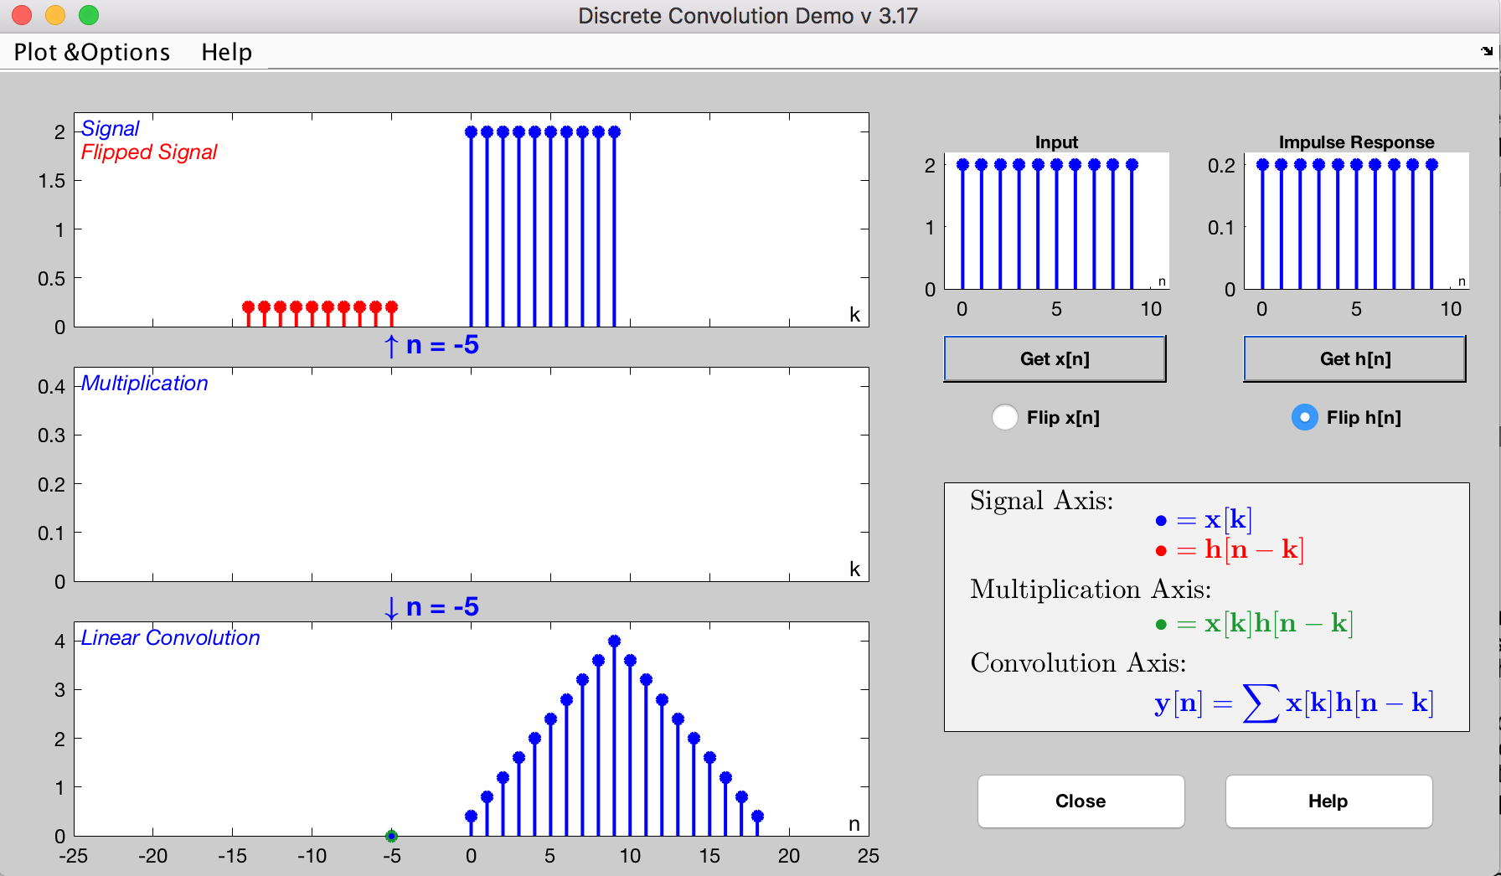

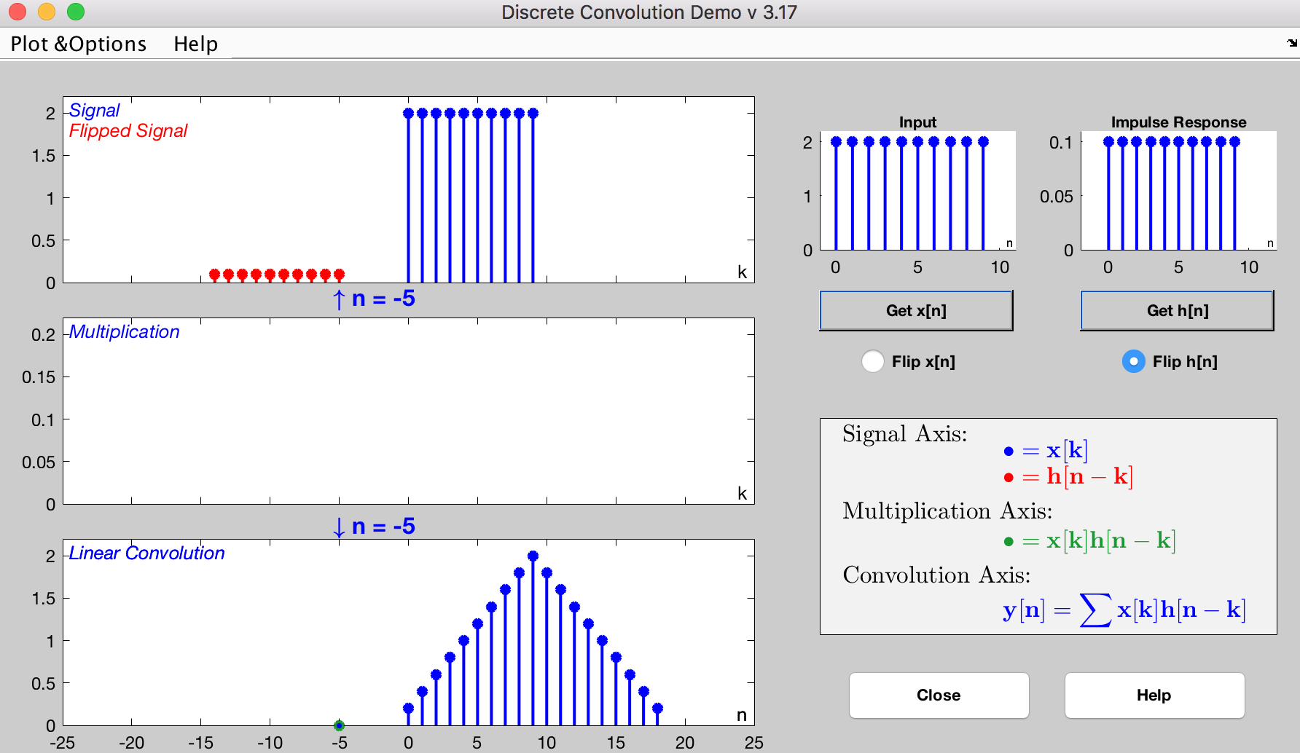

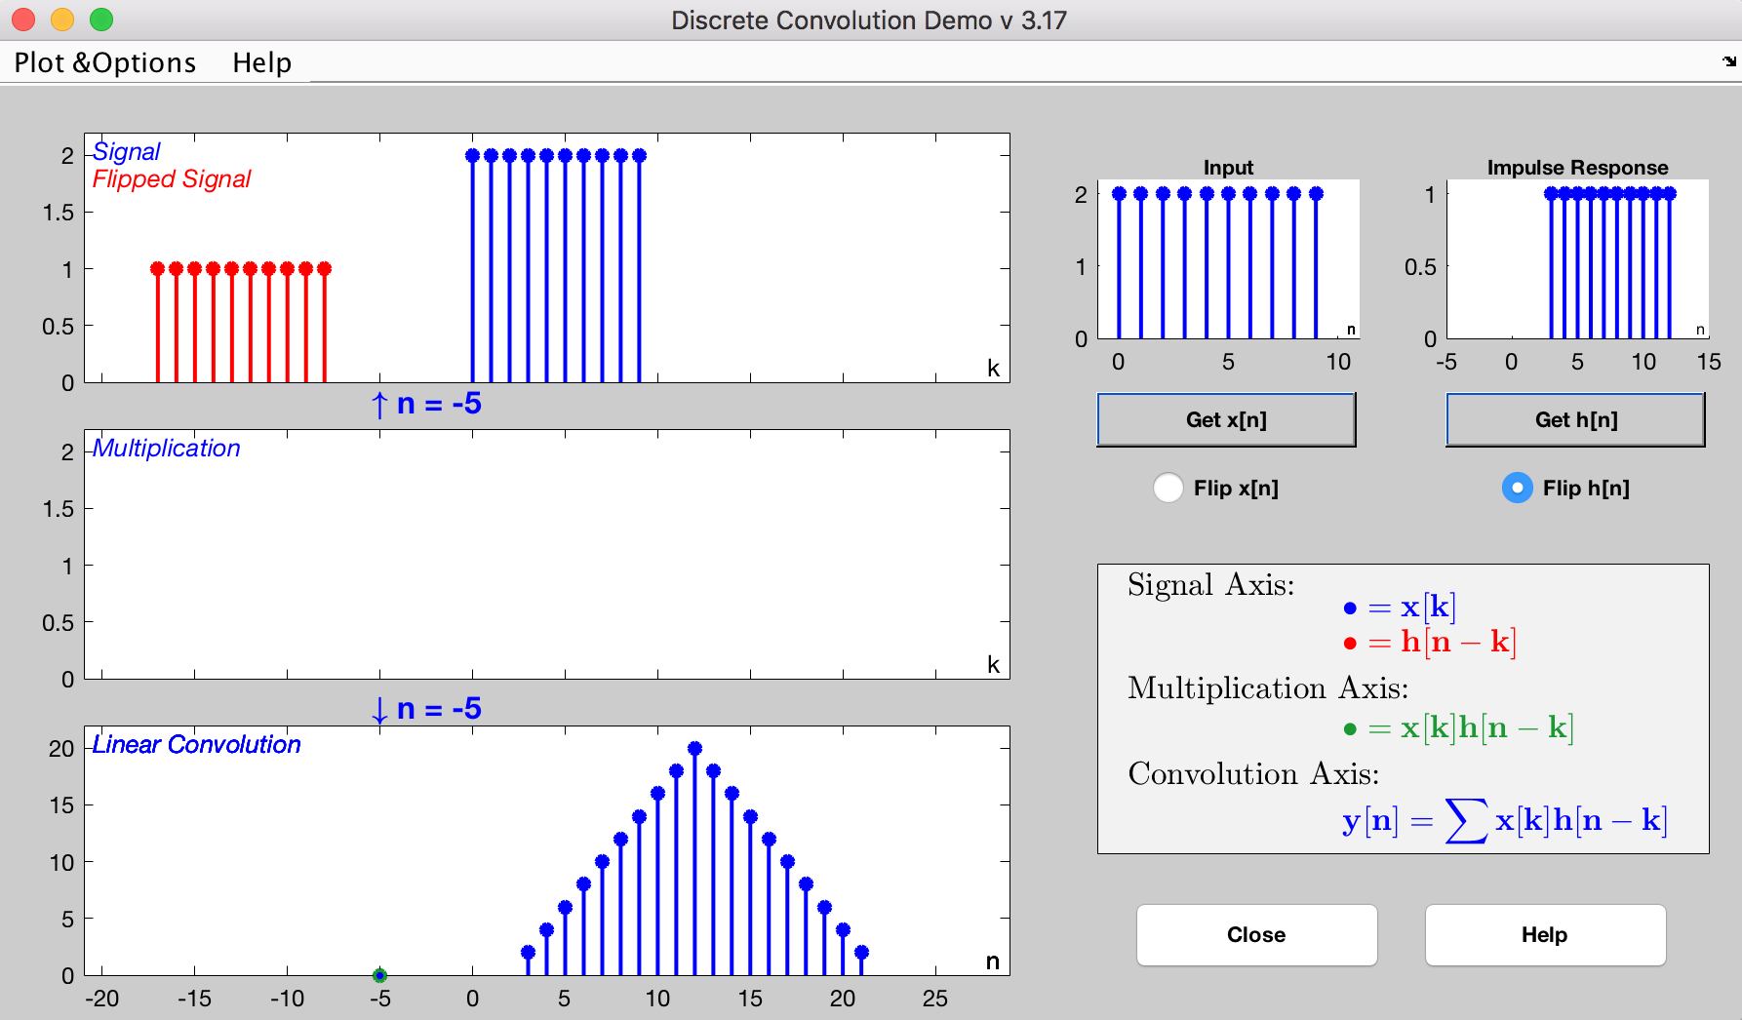

2.2

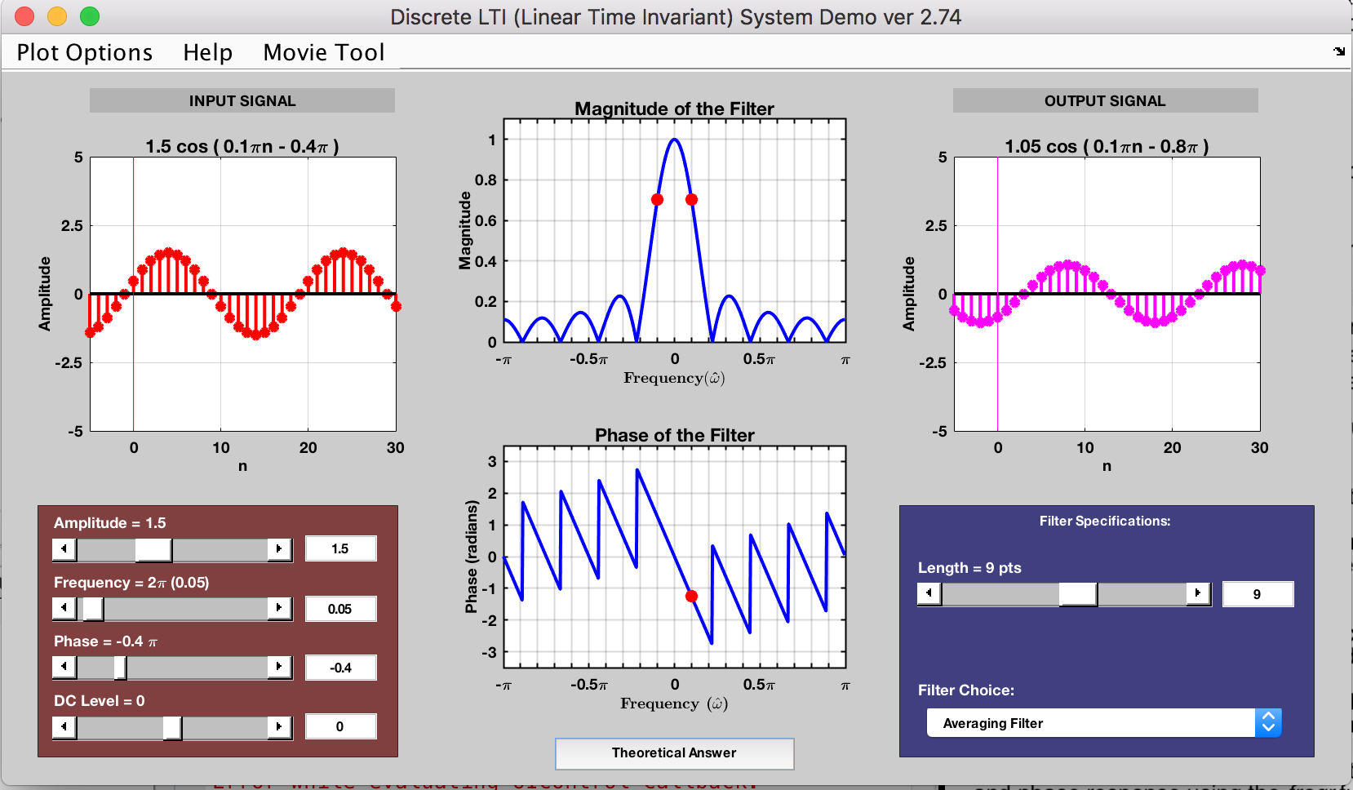

The formula for the output of the signal y[n] = 1.05 cos(0.1\*pie\*n – 0.8\*pie)

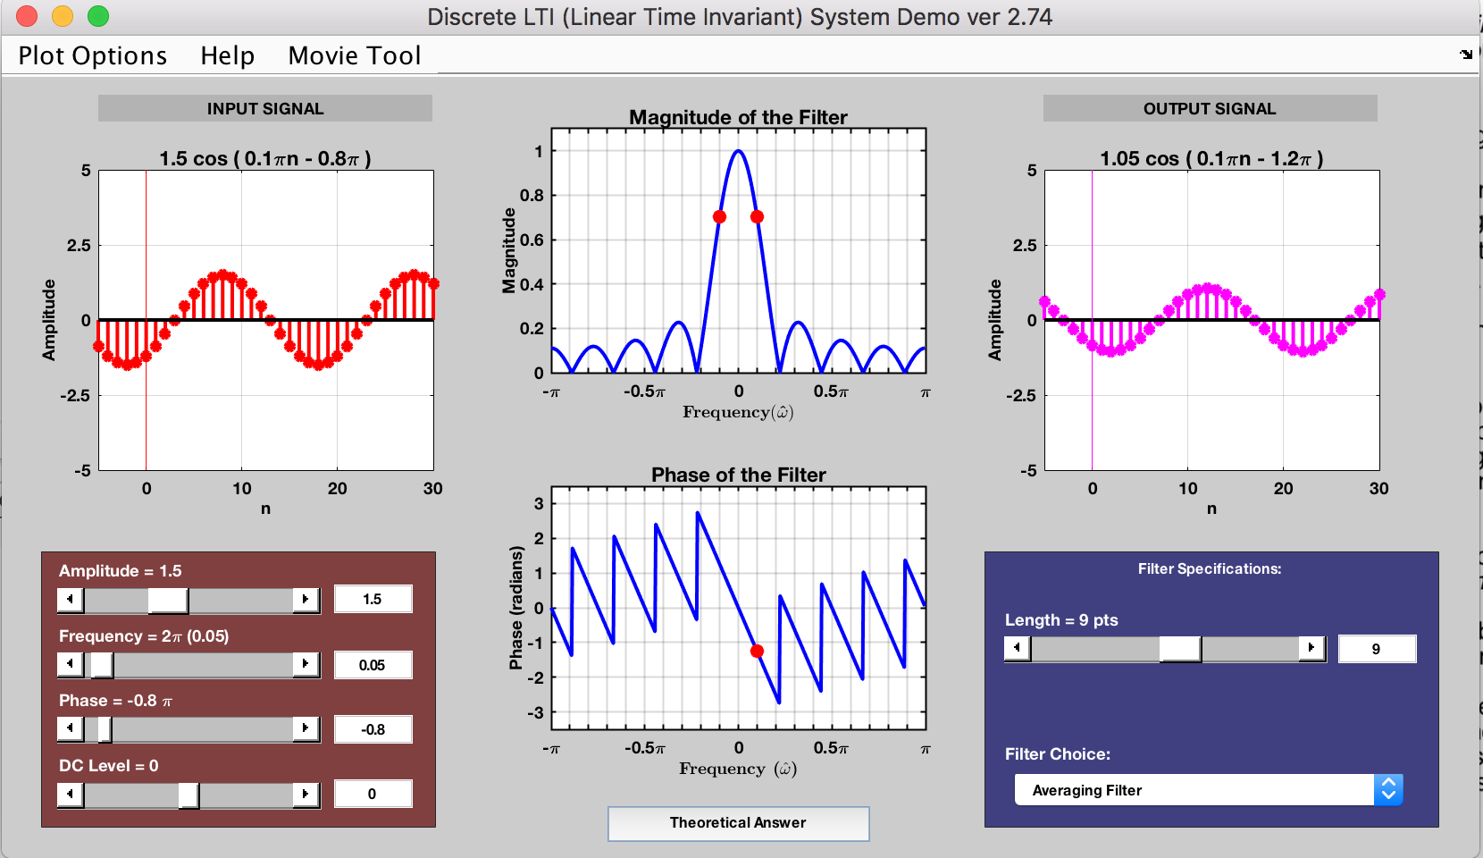

The peak of the cosine wave has been delayed by 3.

3.

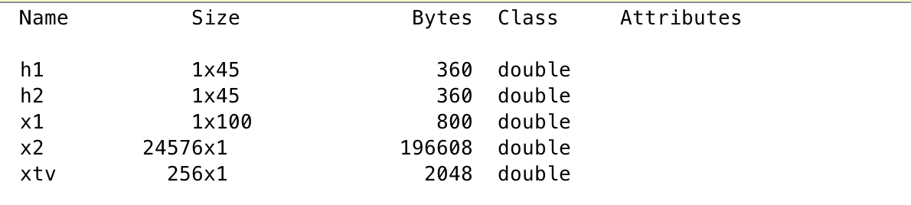

Exercise 4:

function y=filterfir(h, x)

h=[0 1 2];

x=[2 4 1];

y=filterfir(h, x)

lenh=length(h); lenx=length(x); leny=lenh+lenx-1;

% Make an empty Y vector in the same direction as X if size(x, 1)==lenx

y=zeros(leny, 1);

else

y=zeros(1, leny); end

for k=1:lenh y(k:k+lenx-1)=y(k:k+lenx-1)+h(k)\*x; end

return; % End of the function

function freqr(h)

h=[1 2 1];

N=200; % number of frequencies to evaluate

omega=-pi:2\*pi/N:pi;

FF=exp(-j\*omega’\*(0:length(h)-1));

H=FF\*h(:); % The frequency response mH=abs(H); % The magnitude response pH=angle(H); % The phase response

subplot(2, 1, 1); plot(omega, mH);

xlabel(’\omega’); ylabel(’|H(\omega)|’); title(’magnitude response’); h=gca; grid on;

set(h, ’XLim’, [-pi, pi]); % set x axis limit

set(h, ’XTick’, [-pi: 0.25\*pi: pi]); % X axis tick positions set(h, ’FontName’, ’symbol’); % prepare to type tick label set(h, ’XTickLabel’, ’-p||-0.5p||0||0.5p||p’);% tick label

subplot(2, 1, 2); plot(omega, pH);

xlabel(’\omega’); ylabel(’\angle H(\omega)’); title(’phase response’); h=gca; grid on;

set(h, ’XLim’, [-pi, pi]); % set x axis limit

set(h, ’XTick’, [-pi: 0.25\*pi: pi]); % X axis tick positions

set(h, ’FontName’, ’symbol’); % prepare to type tick label

set(h, ’XTickLabel’, ’-p||-0.5p||0||0.5p||p’);% tick label return;

Exercise 5: I observe a different shape of the signals.

Exercise 6: The filtered version is little unpleasant to hear, since it contained a filtered wave.